Decisions
Crossy Road
Decision making is important when there will be situations with multiple options and an option needs to be selected based on the given conditions.
Example: When playing a game, if number of lives = 0, its game over
Penguin to cross the road and get to the other side!
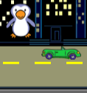
Get Ready
- Add Backdrop: street Sprites: Car and Penguin (set sizes to 40)
Add your code
- Car: When green flag is clicked, set Rotation style left – right, size – 40%. Forever, move 5 steps, if on edge, bounce
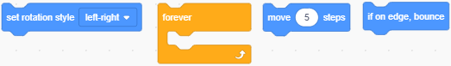
- Penguin: When green flag is clicked - Forever, if UP arrow key is pressed, change y by 10
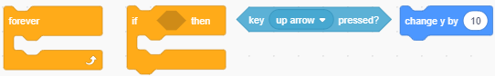
- Penguin: Inside Forever; If DOWN arrow key is pressed, change y by -10
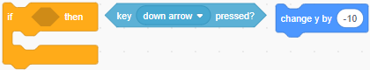
- Penguin: Inside Forever; If RIGHT arrow key is pressed, change x by 10
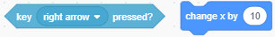
- Penguin: Inside Forever; If LEFT arrow key is pressed, change x by -10
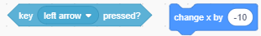
- Penguin: Inside Forever; If Penguin touches the car, say “Ouch!” and go back to its start position
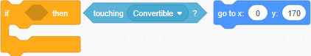
Try it out!
- See what happens when you try to cross the road. Watch out for the cars!
Challenge!
Bruise Penguin
Make a variable “Injuries”. When penguin touches car, change “Injuries” by 1 and change whirl effect (Hint: Look at “Change color effect” block).
Add more cars
Add 2 additional car sprites, moving at different speeds
Add background music
Using a forever loop, play a music loop “Dance Magic”
Energy Boost – New Project
Add sprite Robot. Make variable Energy. Using FOREVER loop, IF it touches mouse-pointer, change Energy by 1000.
Test Yourself!
Do these two pieces of Scratch code do the same thing after the green flag has been pressed?
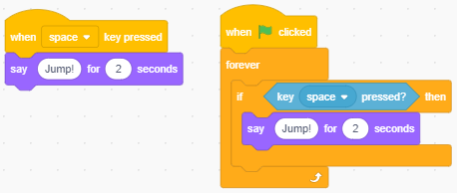
Yes
No
Do you see a decision?

